**This is PYTHON Code for Random Forest Tree**

**(need install pandas, numpy, seaborn, matplotlib, bib and sklearn)**

import pandas as pd

import numpy as np

dataset =pd.read_csv("H:\data1.csv")

dataset.head()

**Output**

Gender AGE Urea Cr HbA1c Chol TG HDL LDL VLDL BMI CLASS

0 0 50 4.8 62 5.9 5.3 1.3 1.0 3.7 0.6 19.0 Diabetes_1

1 0 50 4.8 62 5.9 5.3 1.3 1.0 3.7 0.6 19.0 Diabetes_1

2 0 77 5.0 106 5.4 0.0 2.8 0.8 1.8 0.7 19.0 Diabetes_0

3 1 33 2.7 47 6.0 4.2 1.4 1.3 2.6 0.7 19.0 Diabetes_1

4 0 30 6.0 97 5.8 4.2 1.7 1.2 2.2 0.8 19.0 Diabetes_1

>>> dataset.info()

<class 'pandas.core.frame.DataFrame'>

RangeIndex: 1000 entries, 0 to 999

Data columns (total 12 columns):

# Column Non-Null Count Dtype

--- ------ -------------- -----

0 Gender 1000 non-null int64

1 AGE 1000 non-null int64

2 Urea 1000 non-null float64

3 Cr 1000 non-null int64

4 HbA1c 1000 non-null float64

5 Chol 1000 non-null float64

6 TG 1000 non-null float64

7 HDL 1000 non-null float64

8 LDL 1000 non-null float64

9 VLDL 1000 non-null float64

10 BMI 1000 non-null float64

11 CLASS 1000 non-null object

dtypes: float64(8), int64(3), object(1)

memory usage: 93.9+ KB

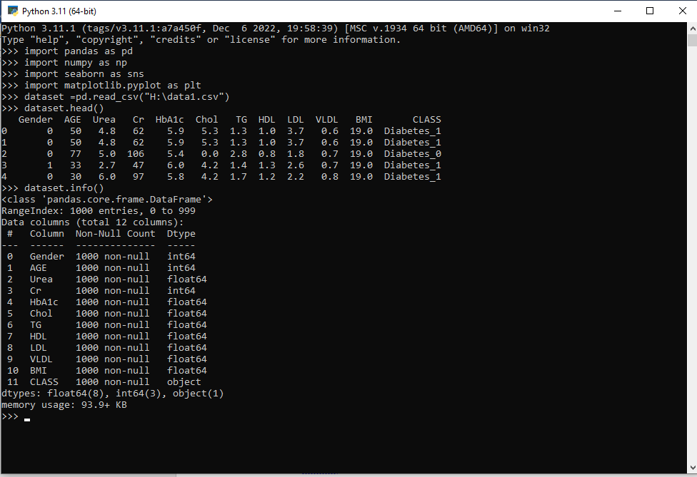

import seaborn as sns

dataset.info()

dataset.describe().T # T transposes the table

import matplotlib.pyplot as plt

g = sns.pairplot(dataset, hue='CLASS')

g.fig.suptitle("Scatterplot and histogram of pairs of variables ", fontsize = 14, y=1.05);

plt.show()

**OUTPUT**

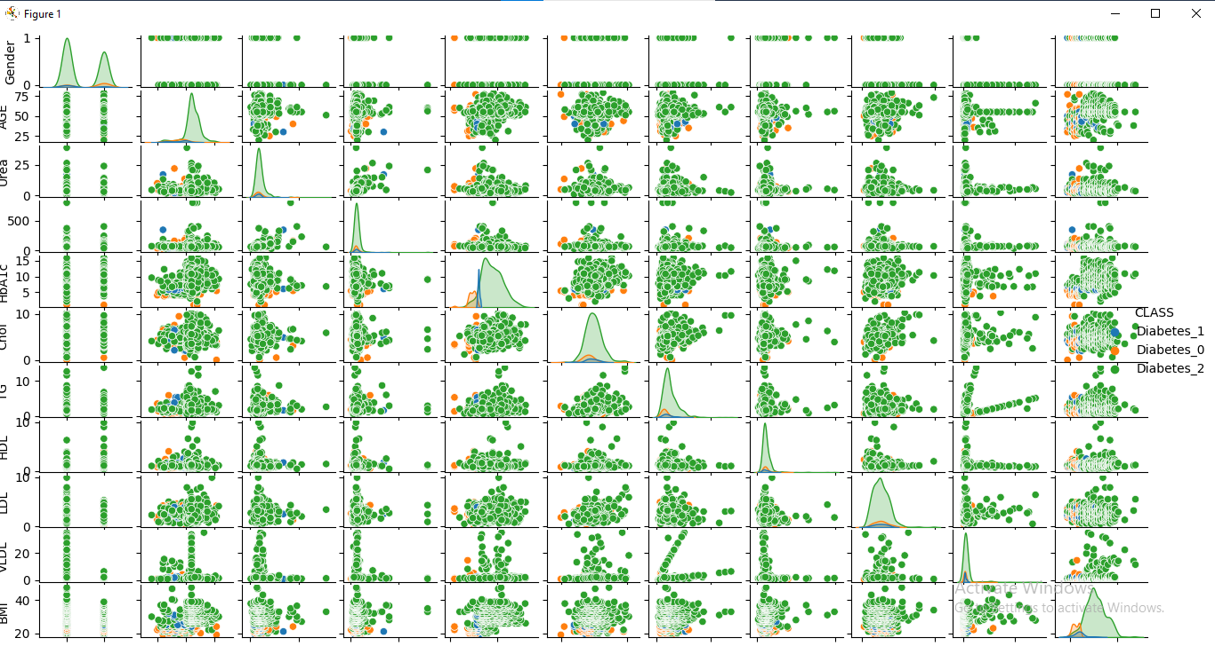

dataset['CLASS'].unique()

**OUTPUT (to convert names into numbers)**

array(['Diabetes_1', 'Diabetes_0', 'Diabetes_2'], dtype=object)

g = sns.pairplot(dataset, hue='BMI')

g.fig.suptitle("Scatterplot and histogram of pairs of variables ", fontsize = 14, y=1.05);

plt.show()

**OUTPUT**

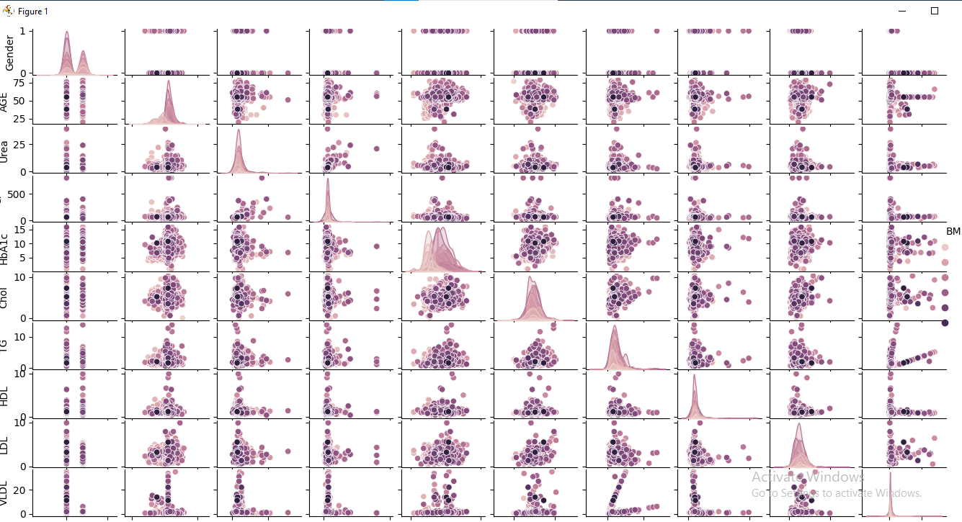

**(replacing strings with numbers)**

dataset[' CLASS '] = dataset[' CLASS '].replace(' Diabetes_1 ', 0);

dataset[' CLASS '] = dataset[' CLASS '].replace('Diabetes_0', 1);

dataset[' CLASS '] = dataset[' CLASS '].replace('Diabetes_2', 2);

y = dataset['CLASS']

X = dataset.drop(['CLASS'], axis=1)

**(Splitting data into training and testing)**

from sklearn.model_selection import train_test_split

SEED = 42

X_train, X_test, y_train, y_test = train_test_split(X, y, test_size=0.2, random_state=SEED)

**(selecting 20% of data to test)**

from sklearn.ensemble import RandomForestClassifier

rfc = RandomForestClassifier(n_estimators=3, max_depth=2, random_state=SEED)

# Fit RandomForestClassifier

rfc.fit(X_train, y_train)

# Predict the test set labels

**(calculating the accuracy of Diabetic Dataset)**

y_pred = rfc.predict(X_test)

**(Calculate the Confusion matrix)**

from sklearn.metrics import classification_report, confusion_matrix

cm = confusion_matrix(y_test, y_pred)

sns.heatmap(cm, annot=True, fmt='d').set_title(The confusion matrix (0 = Diabetes_1, 1 = Diabetes_0, 2 = Diabetes_2)')

print(classification_report(y_test,y_pred))

features_df = pd.DataFrame({'features': rfc.feature_names_in_, 'importances': rfc.feature_importances_ })

To cite this please refer to

**Sahar J. Mohammed, Ali S. Ahmed and Mohammed S. Mohammed, “Feature Minimization for Diabetic Disorders High Performances prediction system based on Random Forest Tree”. 2023**